
Company
Logotype

Cone Beam Computed Tomography- Report



Porur Dental X-rays & CBCT

Patient Name : Mr. Balaraman | Date of Report : 15.12.2023
Age/ Gender : 76 years/ Female | Region of Interest : CBCT Full Skull
Referring doctor: Dr. Shobana Devi | Indication : Implant assessment
Clinical Notes: Nil
PATIENT INFORMATION

CBCT- Full skull provided
CBCT – IMAGE DETAILS

RADIOGRAPHIC INTERPRETATION

- Completely missing crown and root in relation to 14, 15, 16, 17, 18, 22, 24, 25, 26, 27, 34, 35, 36, 37, 38, 42, 43, 44, 45, 46, 47.
- Root stumps: 11, 12, 13, 21, 23, 28
- Presence of bone loss extending beyond the apical third of all teeth that are present.
- Crown in relation to 31, 32, 33, 41, 42, 48.

IMPLANT ASSESSMENT

 | 11 region | 12 region | 13 region | 14 region | 21 region | 22 region | 23 region | 24 region
Sub-Crestal | 6.6 | 5.6 | 5.9 | 4.3 | 7.1 | 1.6 | 6 | 3.6
Mid- Crestal | 7 | 5.8 | 5.7 | 5.4 | 7.7 | 2.4 | 5.8 | 5.2
Distance between the alveolar ridge and Floor of the Nasal cavity (in mm) | 20 | 18.9 | 18.9 | 20.8 | 21.9 | 17.3 | 18 | 19.4

 | 15 region | 16 region | 17 region | 25 region | 26 region | 27 region
Sub-Crestal (in mm) | 5.4 | 5.7 | 8.1 | 3.3 | 4.6 | 6.6
Mid- Crestal (in mm) | 6.9 | 7.6 | 9.2 | 5.2 | 6.1 | -
Distance between the alveolar ridge and floor of the maxillary sinus (in mm) | 11.1 | 6.9 | 6.3 | 9.4 | 5.1 | 3.4

 | 31 region | 32 region | 33 region | 34 region | 41 region | 42 region | 43 region | 44 region
Sub-Crestal | 5.3 | 6.2 | 7.1 | 4.6 | 5.4 | 4 | 4 | 4.7
Mid- Crestal | 5.1 | 6.3 | 6.4 | 5.9 | 5.1 | 5.4 | 5.1 | 6.5
Distance between the alveolar ridge and lower border of mandible (in mm) | 25.2 | 28.2 | 26.6 | 28.4 | 28.9 | 28.7 | 27.2 | 27.4

 | 35 region | 36 region | 37 region | 45 region | 46 region | 47 region
Sub-Crestal (in mm) | 3.5 | 2.8 | 2.9 | 3.3 | 4.1 | 3.8
Mid- Crestal (in mm) | 4.5 | 3.8 | 3.5 | 5.2 | 5.7 | 5.5
Distance between alveolar ridge and the inferior alveolar nerve canal (in mm) | 14.1 | 14.4 | 15 | 14 | 14.1 | 14.5
Distance between the alveolar ridge and lower border of mandible (in mm) | 26.6 | 24.8 | 24.4 | 26.6 | 25.6 | 25.7

RADIOGRAPHIC IMPRESSION

- Partially edentulous maxillary and mandibular arch.
- Root stumps: 11, 12, 13, 21, 23, 28
- Generalized Chronic Periodontitis.

Kindly correlate with clinical findings


IMAGES FOR REFERENCE

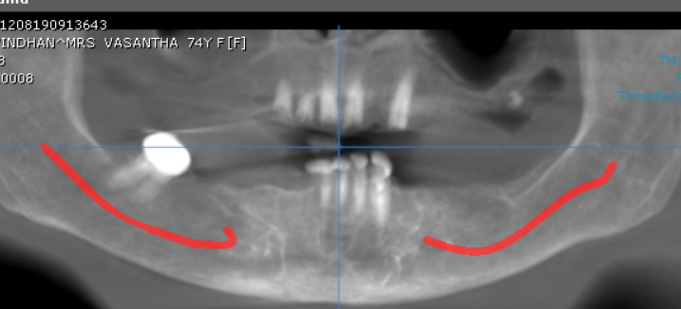

3-DIMENSIONAL VIEW

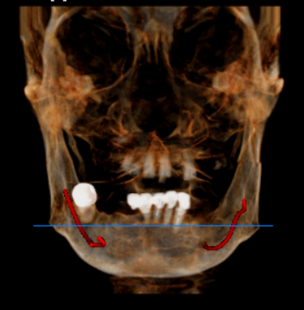

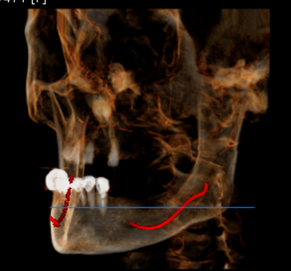
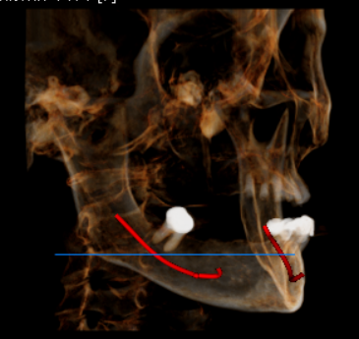

CROSS SECTIONAL VIEW

11 region | 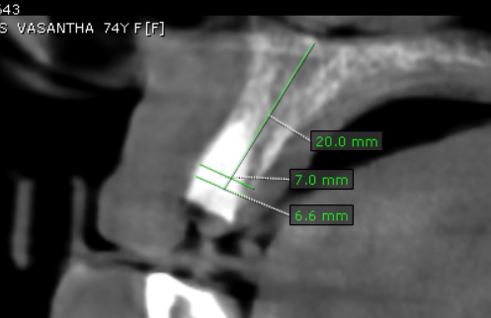
12 region | 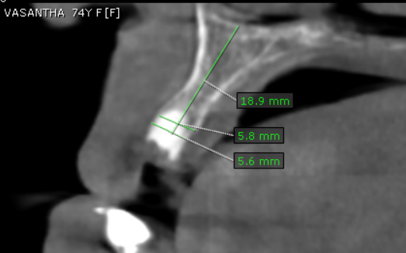
13 region | 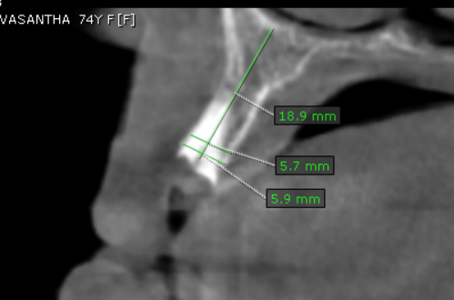
14 region | 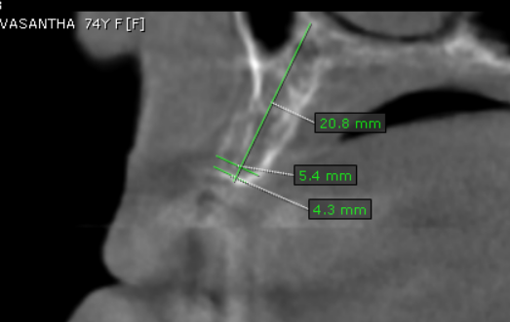
15 region | 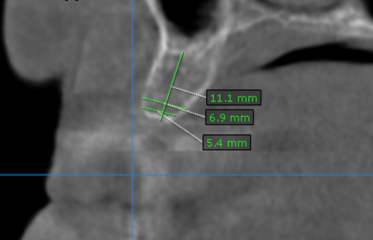
16 region | 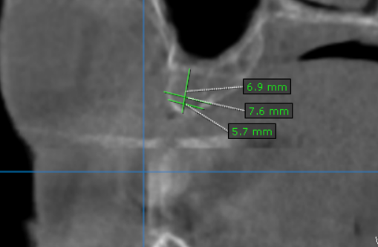
17 region | 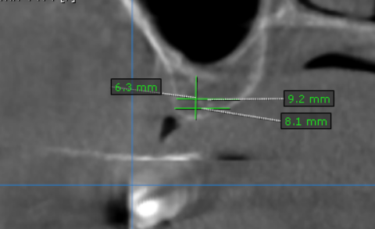
21 region | 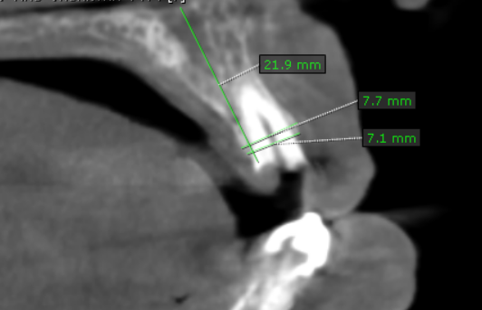
22 region | 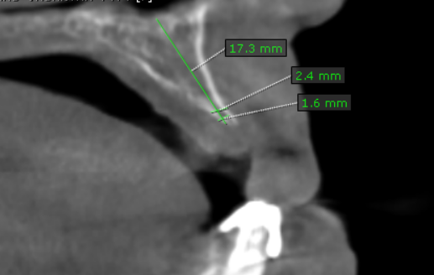
23 region | 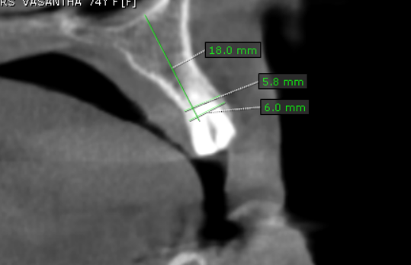
24 region | 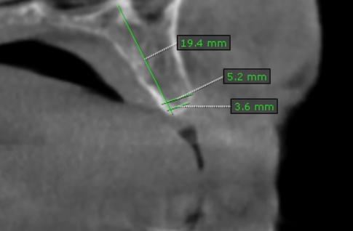
25 region | 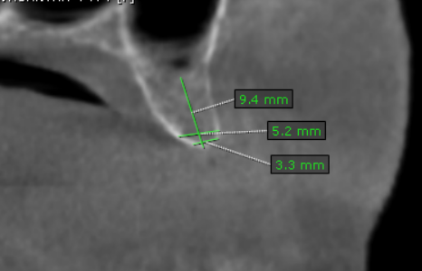
26 region | 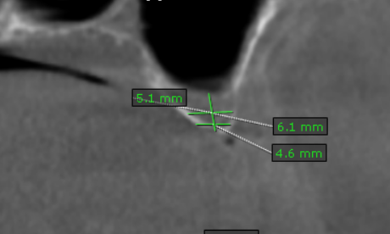
27 region | 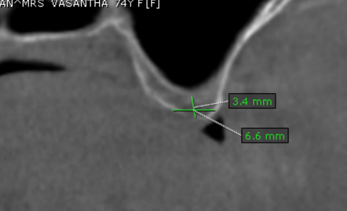
31 region | 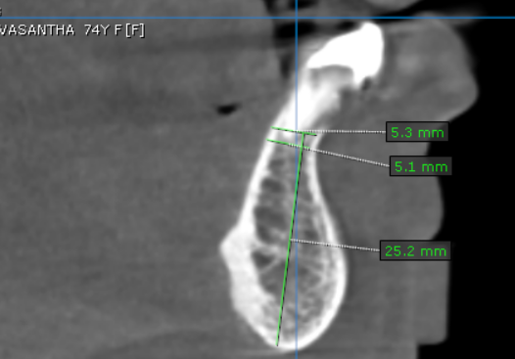
32 region | 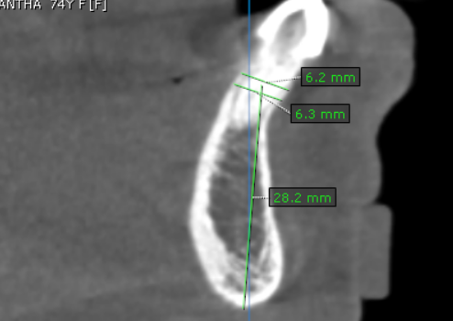
33 region | 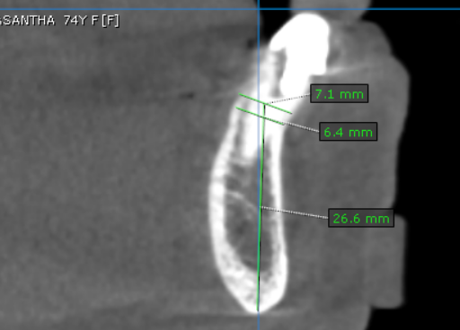
34 region | 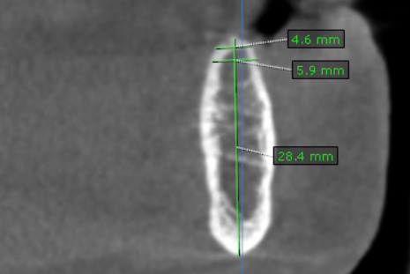
35 region | 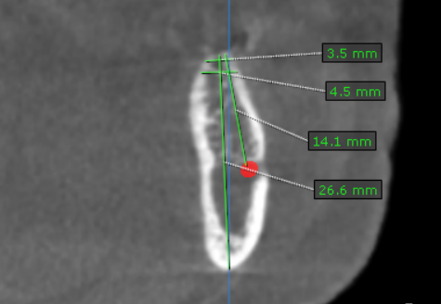
36 region | 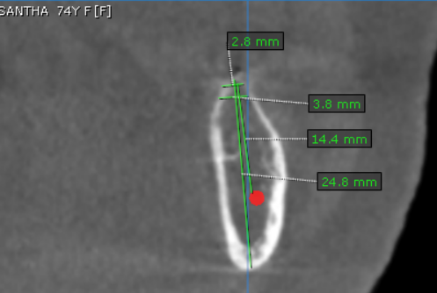
37 region | 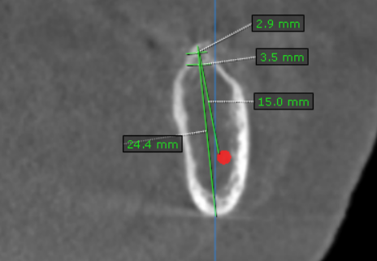
41 region | 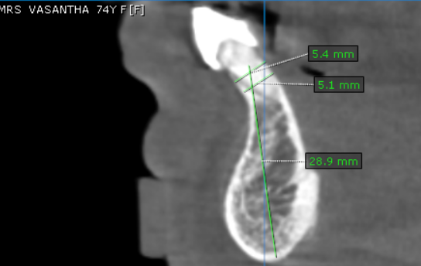
42 region | 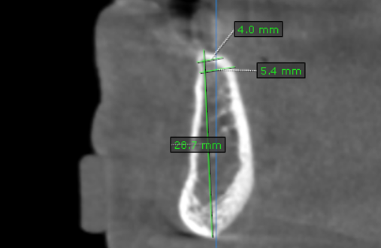
43 region | 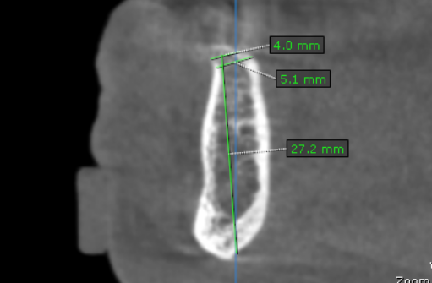
44 region | 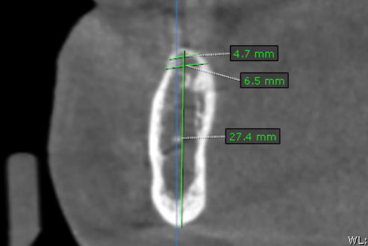
45 region | 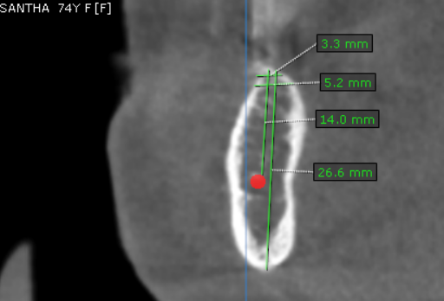
46 region | 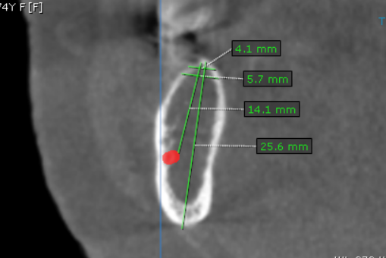
47 region | 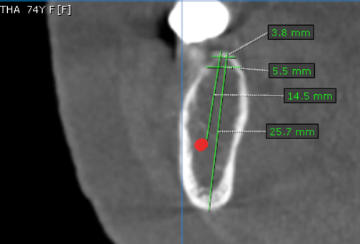

**** End of report ****

